200 MW USED DIESEL POWER PLANT for Sale
(4x50 MW UNITS) MAN-ABB Engine Generator Sets
50Hz. 11kV HFO 103rpm
Commissioned 1999
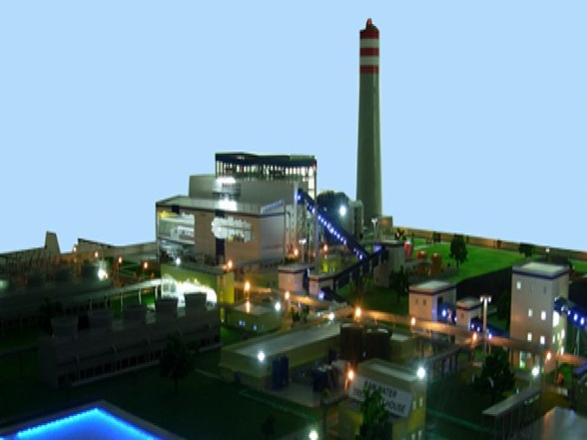

Executive Summary
Plant Overview: The plant is a 200-MW LSHS (low sulphur heavy stock) fuel (processed from the residue of indigenous crude). The plant is based on two-stroke diesel engine technology from MAN B&W, Germany. There are 4 Units of 50 MW each and the plant is in running condition with minimum self-breakdown record. The plant was commissioned in the year 1999. The generator which is of ABB make generates electricity at 11KV. The engines and equipment are water cooled. A recirculation type cooling water system using fresh water with cooling towers is provided. The engines are housed in a building with adequate maintenance facilities like EOT Crane, hoists, etc. The main control room is also located in this building. The engine room is provided with mechanical ventilation system and the control room is air conditioned. The power plant has facilities for unloading, storage and supply of fuel oil to the engines. Separate tanks for HFO and LDO are provided. Water treatment facilities for cooling water system and to produce demineralized water for the waste heat recovery boilers are provided. Suitable Fire protection system to protect the equipment fire hazards is provided.
The main engines have been presently used only as a peaking power plant and are very well maintained. These engines have balance useful life of at least 20 years with proper maintenance as recommended by OEM.
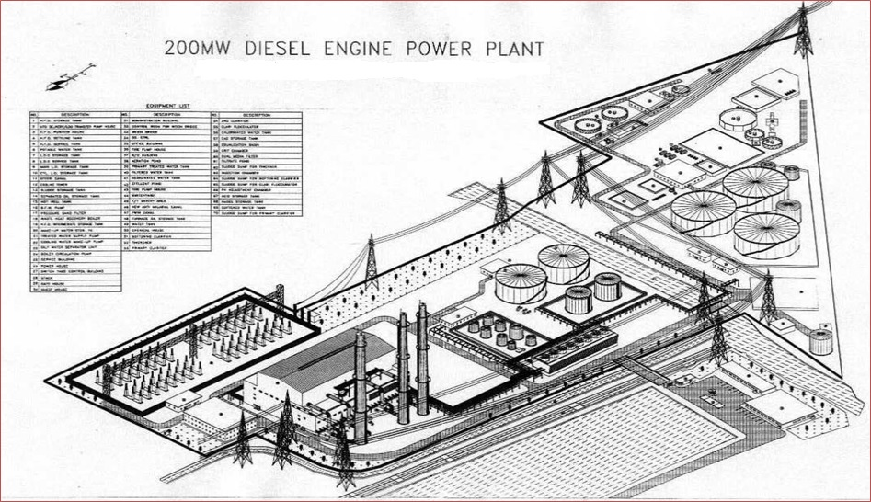
Figure 1: Plant Map

- Technical Details

Type of Station | Diesel
Station Capacity | 200MW (4x50 MW)
Fuel | LSHS & LDO
Transportation | Ship, Cross Country pipe line
Consumption | 810 Tonnes per day
Cooling Water Source | Sewage Treatment Plant
Water Consumption Requirement | 30 m3/hr
Chimney | RCC Chimney with Flue height 100 meters
Design Heat Rate | 7400BTU/kWhr

- Main Engine

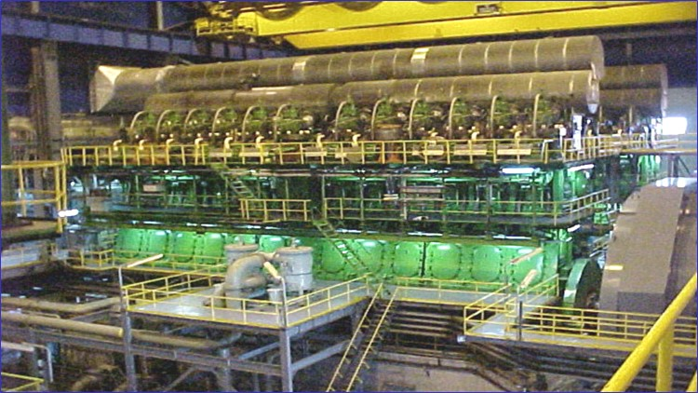
Manufacturer | M/s Hyundai Heavy Industries Co. Ltd.
Engine Type | HYUNDAI-MAN B&W,2-Stroke,single acting, cross-head, exhaust turbocharged type diesel engine
Model | 12K90MC-S
Number of Cylinder | 12
Cylinder Bore | 900 | mm
Stroke | 2300 | mm
At Max. continuous rating
Output | 51480 | kW
Revolution | 103.4 | rpm
Mean effective Pressure | 17 | bar
Max.Pressure | 145 | bar
Mean piston speed | 145 | m/s
Net Weight | 1810 | ton
Direction of rotation | Clock wise, looking from aft
Cooling medium | Cylinder Jacket ------- | Fresh water
 | Piston ------- | Lubricating oil
 | Turbocharger ------- | Fresh water
 | Scav.air cooler ------- | Raw water
Starting System | Compressed air (Max. pressure 30 bar)

- Plant Details
Major systems and equipment for mechanical, electrical, instrumentation & control and civil works are given below:

Fuel oil System
FO transfer Pump
FO Supply Pump
FO Circulating Pump
FO Purifiers
FO Filters
FO Heaters
FO Sludge Pump
FO Drain Pump
Oily Water Separater
Engine room Pit Pump
HFO Treatment room Pit Pump
LDO Supply Pump
Oily Water Separater
HSD Unloding pump
HSD Transfer pump
Lube Oil System
CLO Unloading pump
CLO transfer pump
MLO Unloading pump
MLO Pump
Main lube oil cooler
Used lub oil transfer pump
Lube Oil Sludge system
Lube Oil Filters
Lube Oil Purifiers
Cam Shaft Lub oil Pump
Piston rod filter
Water System
Make up water pump
Cooling water transfer pump
Cooling tower
Air coolers
Jacket cooling water cooler
Jacket water pump
Jacket water preheater pump
Jacket water preheater
Potable water pump
Soft water pump
Air System
Air Compressor
Air tanks
Air drier
Ventilation System
Viscous filters
Air suction Fans
Turbo charger
WHRB
Boilers
Condenser
Boiler Water feed pump
Hot well tank
Exhaust System
C&I
Engine Safety Panel
Digital Engine Control
Distributed Control system
UPS
Paging System
PA System
CCTV System
Master Clock System
Stack Gas Analysers
VMON System
Oil Mist Detectors
Viscosity Meters
Alpha Lubricators
PMI System
Weigh Bridge
I&C systems summary
Electrical
Alternators
Excitation System
Jacking Oil System
Generator Cooling system
Generator Transformers
Unit Auxiliary transformers
Station Transformers
Service Transformers
Lighting Transformers
STP Transformer
HT Motors
Battery Chargers
Switchyard
110kv SF6 Breakers
CVT's
CT's
Line Isolators
Lightening Arestors
Wave Trap
Post Insulator
Tariff Meters
RTU & SCADA
Sewage Treatment Plant
Biological Section
Chemical Section
Reverse Osmosis Section
Post Treatment section
Fire Fighting System
Water Hydrant System
High Velocity Water spray system
Medium Velocity Water Spray system
Foam System
Carbon dioxide-Total floding system
Carbon Dioxde-Spurt System
Protable Fire Extinguishers
Fire Detection & alarm System
Cranes
Water Hydrant System

The main engines have been presently used only as a peaking power plant and are very well maintained.
These engines have balance useful life of at least 20 years with proper maintenance as recommended by OEM.

- Plant Site Pictures
The pictures shown below are indicative in nature. Customers are advised to inspect the material for better understanding.
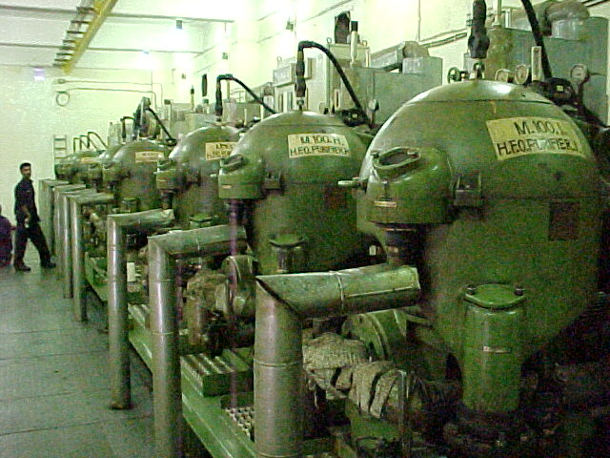
Figure 2: Fuel Oil System

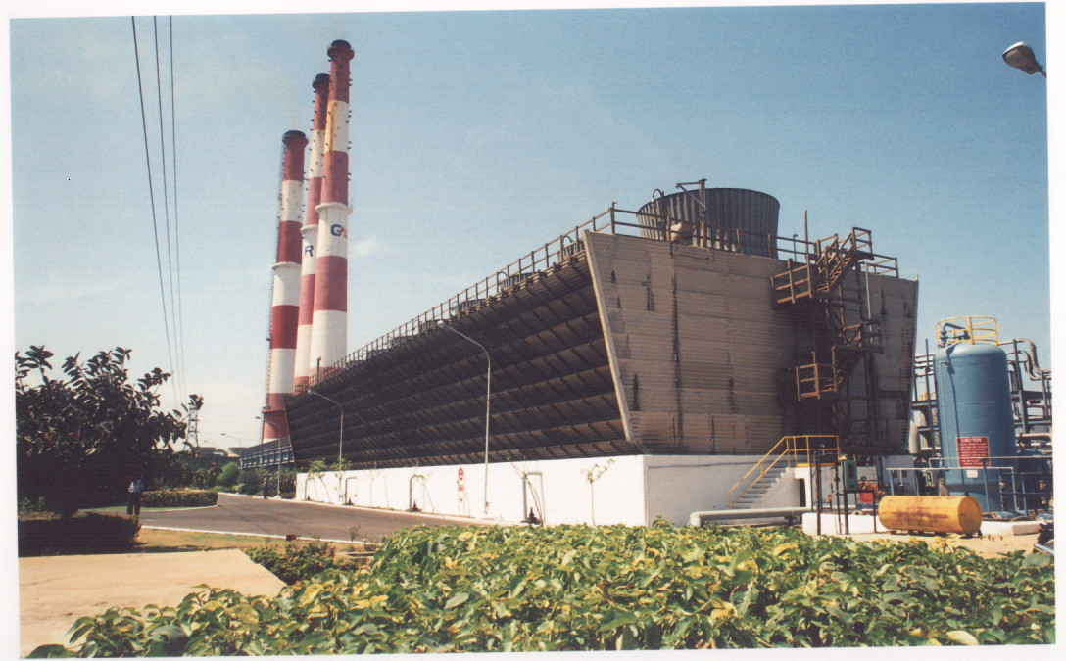
Figure 3: Cooling Water System

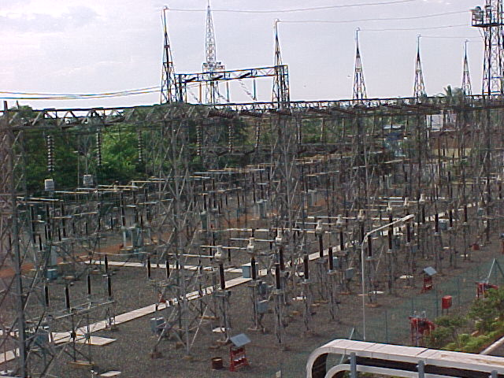
Figure 4: Switchyard

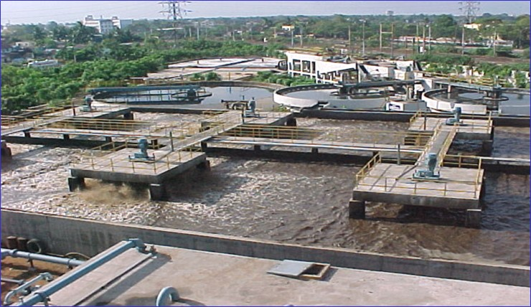
Figure 5: Sewage Treatment Plant

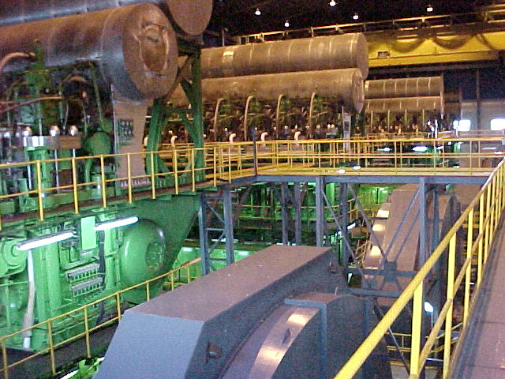
Figure 5: Main Engine

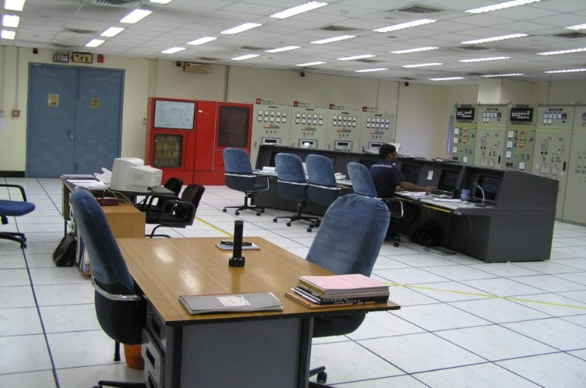
Figure 6: Central Control Room

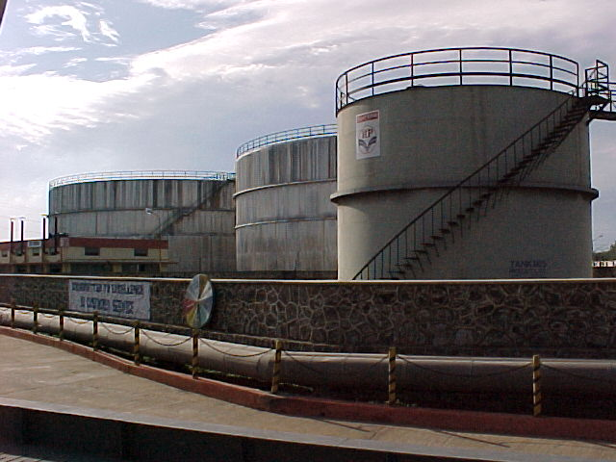
Figure 7: Fuel Oil Storage

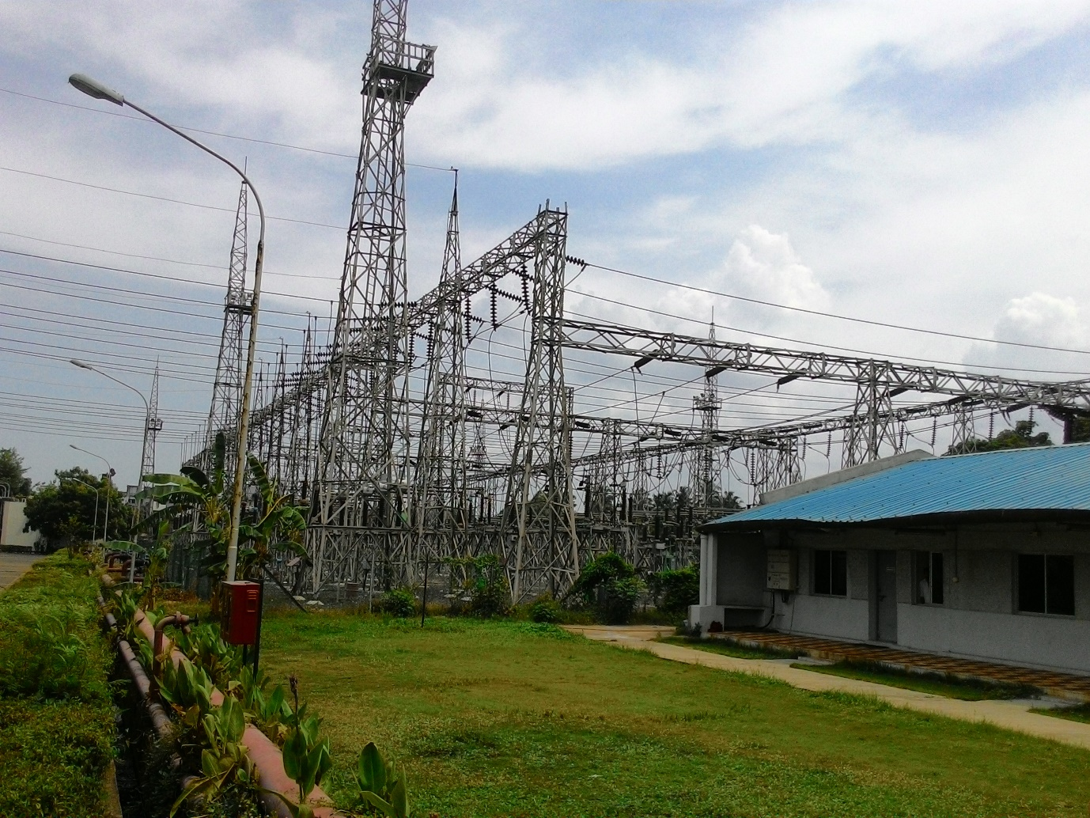
Figure 8: Switchyard

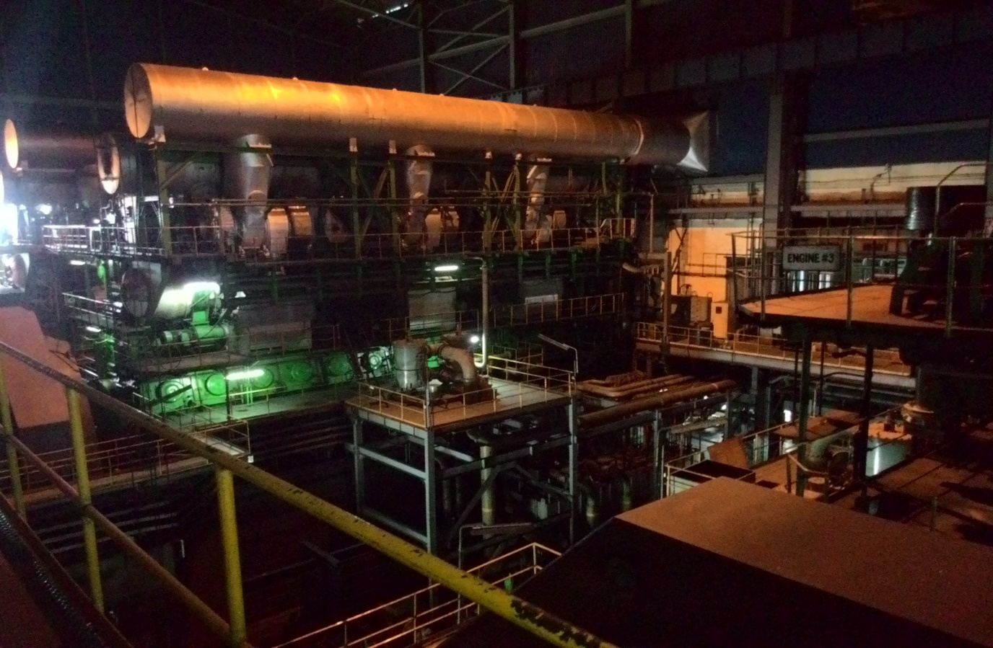
Figure 9: Floor View

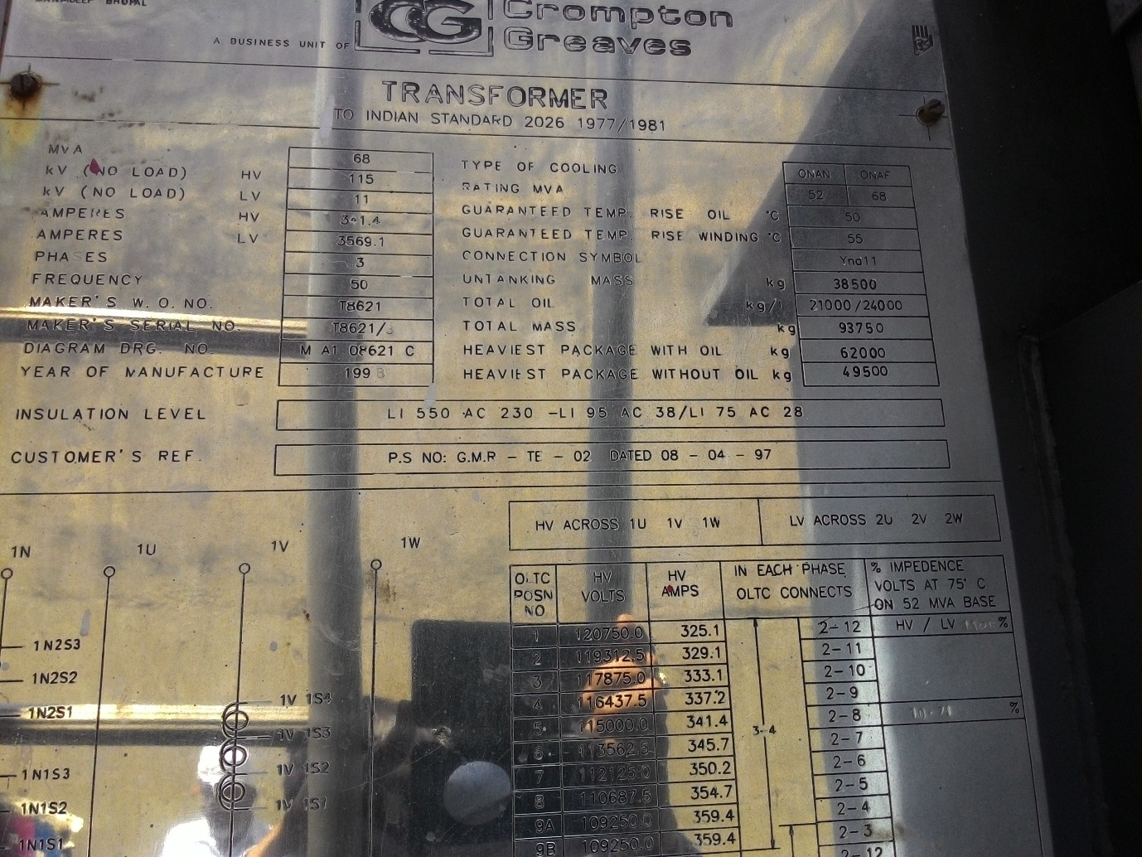
Figure 10: Transformer Plate

